Power BI Dashboard Notes

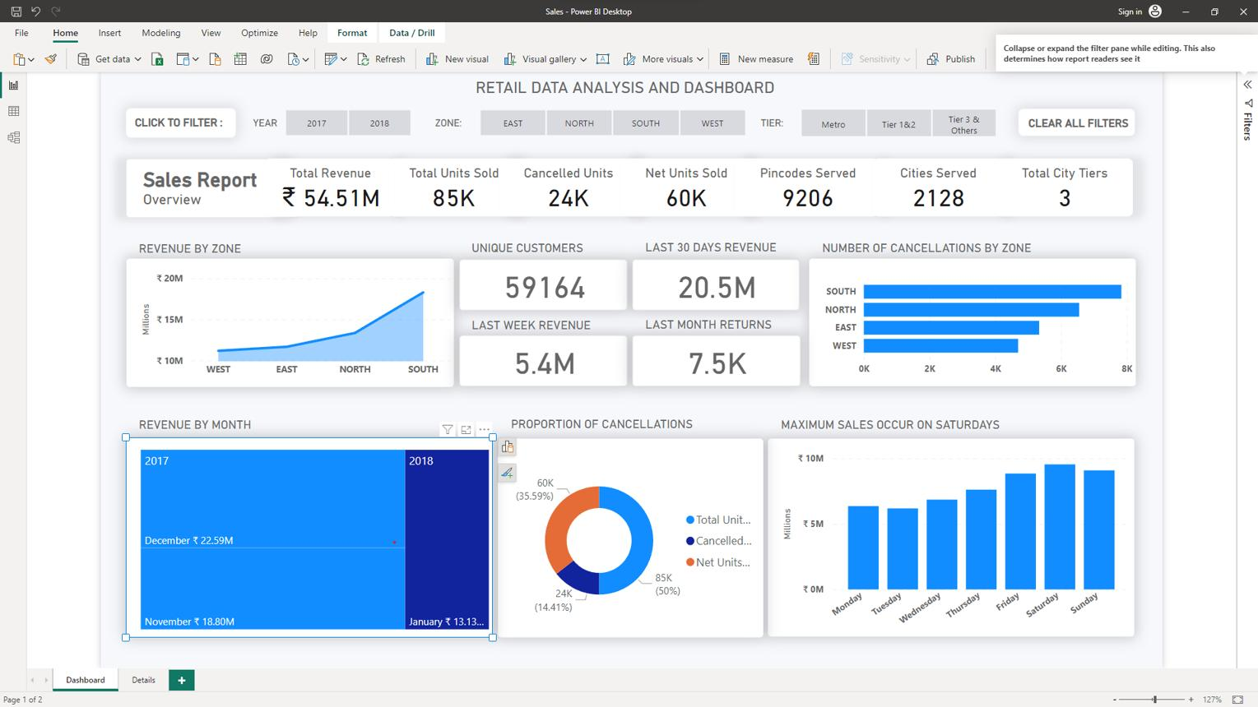
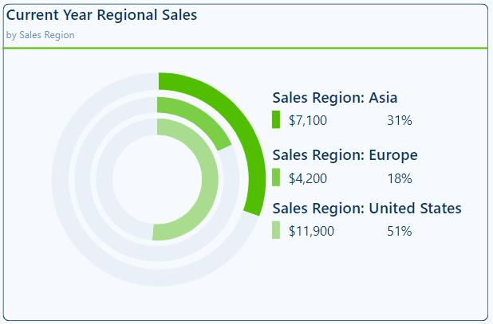
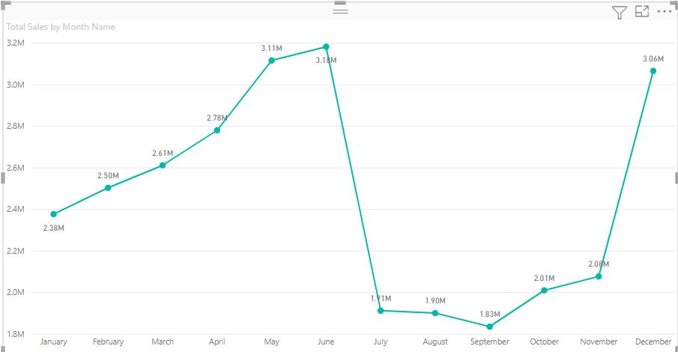
4
Use these notes while explaining your dashboard during the masterclass.

1. Ctrl + /
Shortcut: Ctrl + /
Use this shortcut to quickly search for commands, visuals, settings, or features in Power BI Desktop (Search box).

2. Region Sales – Donut Chart
Fields to Use
- Legend: Region
- Values: Revenue (or Sales)
A Donut Chart shows the percentage contribution of each region to the total sales, making it easy to compare regional performance.

3. Sub-Category Sales – Funnel Chart
Fields to Use
- Category: Product Category (or Sub-Category)
- Values: Revenue
A Funnel Chart ranks categories from highest to lowest sales, helping identify the best-selling and least-performing product categories.

4. State Sales – Map
Fields to Use
- Location: State (or City, depending on your dataset)
- Bubble Size / Color: Revenue
A Map visual displays sales geographically, allowing users to quickly identify high-performing and low-performing locations.

5. Segment Sales – Pie Chart
Fields to Use
- Legend: Segment (or Customer Age Group / Store Type if Segment is unavailable)
- Values: Revenue
A Pie Chart shows the sales distribution among customer segments or store types, highlighting which segment contributes the most.

6. Order Date Sales – Line Chart
Fields to Use
- X-Axis: Order Date (or Month)
- Y-Axis: Revenue
A Line Chart visualizes sales trends over time, making it easy to identify growth patterns, seasonal trends, and sales peaks.

Recommended Power BI Dashboard Layout
---------------------------------------------------------
Bata Showroom Sales Dashboard
---------------------------------------------------------

KPI Cards
---------------------------------------------------------
Total Revenue | Total Orders | Units Sold | Profit | Avg Revenue

---------------------------------------------------------

Revenue by Region (Donut)

Revenue by Product Category (Funnel)

---------------------------------------------------------

Revenue by State/City (Map)

Revenue by Customer Segment (Pie)

---------------------------------------------------------

Monthly Sales Trend (Line Chart)

---------------------------------------------------------

Filters:
Date | Region | City | Product Category | Payment Mode
---------------------------------------------------------

Business Insights
- Which region generates the highest revenue?
- Which product category is the best seller?
- Which state or city contributes the most sales?
- Which customer segment contributes the highest revenue?
- How do sales change over time?
- Which areas need improvement?

